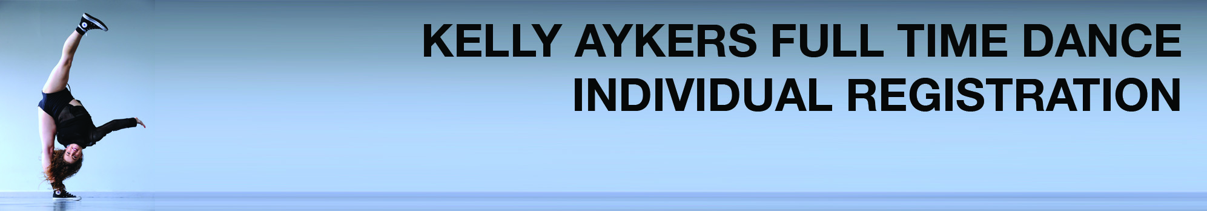

**Applicant Details**

First Name:

Surname:

Address Line 1:

Suburb:

City:

Country:

State:

Postcode:

Mobile Phone:

Email:

Gender:

Nationality:

Which Courses are you applying for?

(You may choose more than one)

Dancer’s Elite

CUA40120 Certificate IV in Dance* - 1 year

CUA40320 Certificate IV in Dance Teaching and Management* - 1 year

CUA50220 Diploma of Musical Theatre*- 2 year

CUA50120 Diploma of Dance (Elite Performance)* - 2 year

Part Time Industry Course

Note:

* Qualification offered in partnership with Australian Teachers of Dancing - RTO#31624

* Note that the CUA50120 Diploma of Dance (Elite Performance) course also includes the CUA40120 Certificate IV in Dance after one year of study.

* Those studying the CUA40120 Certificate IV in Dance will have first option to continue their studies in 2021 to obtain their CUA50120 Diploma in Dance (Elite Performance).

**Previous Training**

List number of years training in:

Jazz years

Ballet years

Tap years

Vocal years

Acrobatics years

Drama years

Contemporary years

Hip Hop years

Other (please list):

Please list places of previous training:

Please list any other relevant experience:

**Emergency Contact**

Emergency Contact Name:

Emergency Contact Number:

**Next of Kin Details**

Name:

Relationship to Student:

Address:

City:

Country:

State:

Postcode:

Mobile Phone:

Email:

Nationality:

**Medical History**

Do you have any health issues or allergies that may affect your ability to audition? Yes No

If Yes, please provide details:

Please list any other relevant information:

In case of emergency, and where a parent or guardian cannot be contacted, do we (Kelly Aykers Full Time Dance) have permission to call an ambulance? Yes No

**Applicant Declaration**

**I agree that in the event of an injury or accident that Kelly Aykers Full Time Dance directors, teachers and employees are in no way responsible. I understand that I am enrolling to audition for Kelly Aykers Full Time Dance at my own risk and agree to pay all medical bills and take full responsibility in the unfortunate incidence that an accident or injury should occur. Kelly Aykers Full Time Dance is not responsible for any loss of property or additional expense incurred while on the studio premisis. I declare that all information contained within this application is accurate to the best of my knowledge and at the time of writing.**

Signature:

Parent / Guardian Signature

(if applicant under 18 years)

Date: